Individual Pathways
Activity 9.3

Investigating energy transmissions further

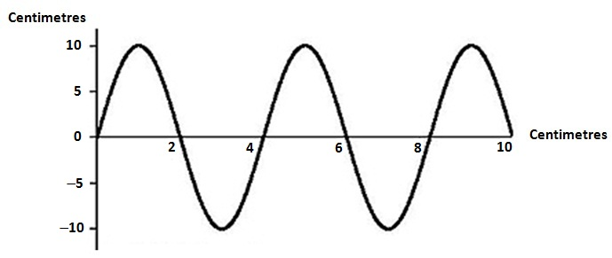

- What type of wave is shown in the diagram above? ......................................................
- What is the wave’s:
(i) wavelength ................................................
(ii) amplitude? .................................................
- Give an example of energy that travels in this type of wave.
.........................................................................................................................................

- Generally, the speed of sound through a material depends upon how close together the particles of that material are and how elastic it is. The greater the ease with which collisions between particles (which transfer kinetic energy) can occur, the faster a sound wave can travel through the material. The following table gives you the speed at which sound waves travel through a variety of materials.

Material | Speed of sound (m/s)
Air (0 °C) | 331
Air (20 °C) | 344
Water (pure) | 1498
Sea water | 1540
Alcohol | 1207
Blood (37 °C) | 1570
Body tissue (37 °C) | 1570
Aluminium | 5100
Copper | 3900
Concrete | 4500
Granite | 5000
Lead | 1960
Glass (Pyrex) | 5170
Iron | 5120
Steel | 4700–6000  (average 5400)
Wood | 4000–5300

- Looking at the values in this table, what generalisation can you make about the speed of sound in liquids compared to its speed in solids and in gases?
...........................................................................................................................................................................................................................................................................................................................................................................................................................
- The wavelength (in metres) of a sound wave as it moves through any material depends upon its frequency (in hertz) and its speed in that material. This relationship can be represented by the equation (wavelength) = (speed) ÷ (frequency). Use this equation to calculate:
- the wavelength of a sound wave that has a frequency of 150 Hz as it passes through copper ..................................................
- the wavelength of a 2000 Hz sound as it moves through granite ………………….
- the frequency of a sound wave that has a wavelength of 2 m when it travels through water. ………………………………...
- Use the particle model to suggest a reason why sound waves travel faster in air at
20 °C than they do at 0 °C.
……………………………………………………………………………………………………………………………………………………………………………………………………………………………………………………………………………….
- In movies you may see someone trying to tell if a train is coming by pressing their ear against the steel rail of the train track. Explain why this would be any better than just trying to hear the sound of the train coming through the air.
....................................................................................................................................................................................................................................................................................................................................................................................................................................................................................................................................................................

- The refractive index (n) of a medium is a measure of how much light is slowed as it travels through a medium. For a vacuum, where light is not slowed at all, n = 1. For Perspex, n = 1.55 and for water n = 1.33.
- If n = (speed of light in a vacuum) ÷ (speed of light in the medium), calculate the speed at which light travels in water. (Take speed of light in a vacuum = 300 000 000 m/s.)
..................................................................................................................................................................................................................................................................................
- A refractometer is a device that measures the refractive index of a material. Oceanographers, marine biologists and even people who breed tropical fish in an aquarium may use refractometers to determine how salty the water is in a tank, pool or ocean region. They are able to do this because there is a linear relationship between the salinity of a water sample (in parts per thousand) and the water sample’s refractive index. This relationship is shown in the following table.

Salinity (ppt) | Refractive Index (20 °C)
0 | 1.33300
30 | 1.33851
31 | 1.33869
32 | 1.33886
33 | 1.33904
34 | 1.33922
35 | 1.33940
36 | 1.33958
37 | 1.33976
38 | 1.33994
39 | 1.34012

- Generate a scatter chart graph of refractive index versus salinity in the space provide below. Complete the graph by inserting labels on each axis and an appropriate title.

- Describe the relationship shown in this graph. ........................................................
- Use both the table and the line graph to help you write an equation that describes the relationship between the salinity and the refractive index. (Hint: This equation will have the form Refractive index = M × (salinity) + C, where M and C will be numbers that you will have to work out from the data.)
............................................................................................................................................................................................................................................................................................................................................................................................................................................................................................................................................
- Water that has more salinity has more salt ions dissolved in it. Explain why salinity would affect the refractive index of the water.
............................................................................................................................................................................................................................................................................................................................................................................................................................................................................................................................................
- In each case, light beams are directed into a box that may contain a mirror (plane, converging or diverging) or a lens (converging or diverging). Use the paths of the resulting light beams to identify the optical device inside each box.
(Note: the rays entering the box are in blue while those leaving the box are in red.)

- Device: .................................................
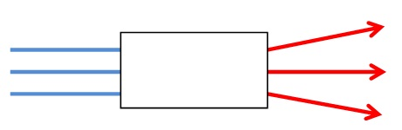

- Device: .................................................
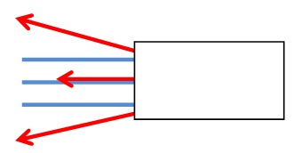

- Explain why people who have normal vision for much of their life may need glasses as they grow older.
................................................................................................................................................................................................................................................................................................................................................................................................................................................................................................................................................................................................................................................................................................................................................

- At the moment, we are in the process of changing over from analogue TV signals to digital TV signals. Give at least two advantages that digital TV will have over analogue TV.
................................................................................................................................................................................................................................................................................................................................................................................................................................................................................................................................................................................................

- Explain how visible light is used to transmit phone calls along optical fibres. You may use diagrams to help you in your explanation if you wish.
................................................................................................................................................................................................................................................................................................................................................................................................................................................................................................................................................................................................................................................................................................................................................

- Repeater stations are often found in the countryside, spaced approximately evenly apart. Where there are hills or mountains, repeater stations are often found on the top of these.

- What type of electromagnetic wave is being transmitted between the repeater stations? ..........................................................
- Why is it preferable to build repeater stations on mountains rather than on plains?
...........................................................................................................................................................................................................................................................................................................................................................................................................................
- Why are repeater stations needed?
...........................................................................................................................................................................................................................................................................................................................................................................................................................

Answers

- Transverse wave

(i) 4 cm
(ii) 10 cm
- Examples may include electromagnetic radiation/light or ocean waves.

- The speed of sound in liquids is higher than it is in gases, but is slower than its speed in solids.

- Wavelength = speed/frequency = 3900/150 = 26 m
- Wavelength = speed/frequency = 5000/2000 = 2.5 m
- Frequency = speed/wavelength = 1498/2 = 749 Hz
- Air particles at 20 °C have more kinetic energy and are vibrating faster and colliding more often. This also means that they are faster to enter areas of low pressure where the sound rarefactions occur and faster to be pushed out of the areas where the higher air pressure compressions occur. As a result, the sound waves are transmitted faster through the warmer air than the cold air.
- The speed of sound in steel is about 5400 m/s as compared to 344 m/s in air. This means that the sound of the train’s approach can be heard through the track long before you would hear it through the air.

- 1.33 = 300 000 000/speed of light in water
Speed of light in water = 300 000 000/1.33 = 225 563 909.77 m/s

(i)
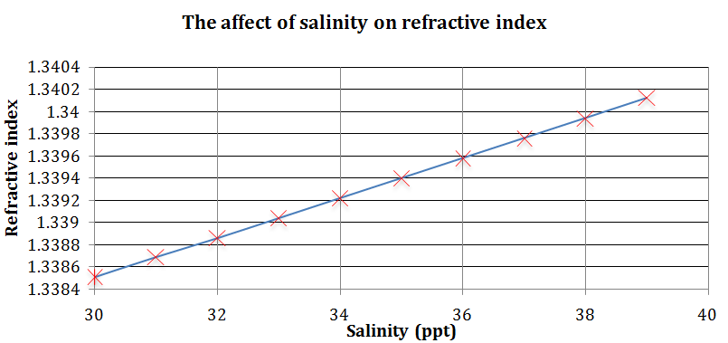
- Linear relationship
- M = gradient = 0.0002; C = Y-intercept = 1.33
Refractive index = 0.0002 (salinity) + 1.33
- The dissolved salt ions increase the density and opacity of the water and cause a certain amount of scattering of the light.

- Diverging lens
- Diverging (concave) mirror

- As people get older, the lens gets more rigid and the ciliary muscles become weaker. This means that the lens is unable to make the bulgier shape required if the person is to form a focussed image of a close object on their retina. Instead, the image tries to form beyond the retina, resulting in a blurry image. To correct this condition (presbyopia), spectacles with converging lenses are needed to help focus the image on the retina. Bifocals — which only have converging lenses in the bottom half — allow the wearer to focus on near objects with correction and to view distant objects without correction.

- Responses may include two of the following.
- Sharper images
- Better sound quality
- Access to internet and email onscreen
- Capability of surround sound option
- Capability of interactive TV options
- Ability to access electronic program guides

- Sound energy is converted into electrical energy. Electrical signals are then converted into pulses of light, which are transmitted along the optical fibres. As the light approaches the outer cladding of the fibre, it bends so much that it is reflected back into the fibre. Therefore, the light is ‘trapped’ inside the fibre.

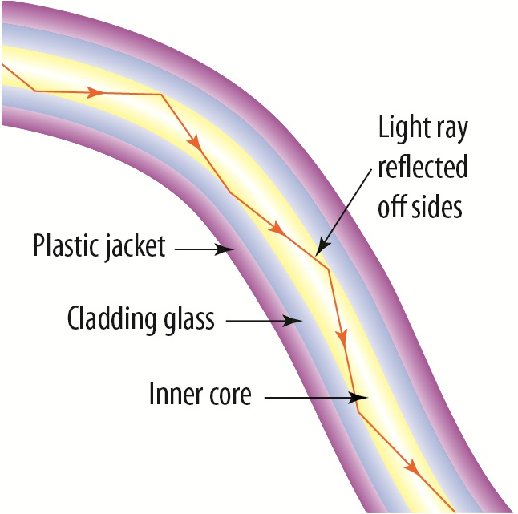

8.
- Microwaves
- Each repeater tower needs to be within sight of the next one because microwaves, like visible light, travel in straight lines. Repeater towers are built on the top of hills wherever possible as they are able to ‘see’ repeater stations further away. Therefore, you would require fewer repeater stations than if you had to build them on a plain.

